**Computer Organization and Architecture (EET2211)**

**LAB IV: Product and Division of Two Numbers without using Arithmetic Instructions**

**Siksha ‘O’ Anusandhan Deemed to be University, Bhubaneswar**

|  |  |  |  |
| --- | --- | --- | --- |
| **Branch:** Computer Science and Engineering **Section:** ‘D’ | | | |
| **S. No.** | **Name** | **Registration No.** | **Signature** |
| 52 | Saswat Mohanty | 1941012407 | **D:\Pics and Sign\sign.jpg** |

**Marks: ______/10**

**Remarks:**

**Teacher’s Signature**

**I. OBJECTIVE:**

1. Multiply two 16 bit numbers without using arithmetic instructions.
2. Divide two 16 bit numbers without using arithmetic instructions.

**II. PRE-LAB**

**For Obj. 1:**

1. **Find the product and quotients of two 16 bit numbers.**

Let the two 16bit numbers be 32(0020h) and 8(03h). Their product is 256 (0100h) and quotient is 3.

1. **Write the assembly code.**

|  |
| --- |
| **org 100h**  **mov ax, 0000h**  **mov ds, ax**  **mov ax,[3000h]**  **mov cl, 02h**  **sal ax, cl**  **mov [3002h], ax**  **hlt**  **ret** |

**For Obj. 2:**

1. **Find the quotient and remainder obtained from division of two 16 bit numbers.**

Let two number be 200(00c8h) and 4(0004h). Quotient is 50 (00032h) and remainder is 0.

1. **Write the assembly code.**

|  |
| --- |
| **org 100h**  **mov ax, 0000h**  **mov ds, ax**  **mov ax,[3000h]**  **mov cl,02h**  **shr ax,cl**  **mov [3002h], ax**  **hlt**  **ret** |

**III. LAB:**

**Assembly Program:**

**For Obj. 1:**

|  |
| --- |
| **; SASWAT MOHANTY**  **; 1941012407**  **; Multiply two 16 bit numbers without using arithmetic instructions.**  **org 100h**  **mov ax, 0000h**  **mov ds, ax**  **mov ax,[3000h] ; Value stored at 3000 = 0030**  **; Binary of 0030 = 0000 0000 0011 0000**  **mov cl, 02h ; We have to perform 2 left shift**  **; After 1st shift -> 0000 0000 0110 0000 = 0060**  **; After 2nd shift -> 0000 0000 1100 0000 = 00C0**  **sal ax, cl ; Output value = 00C0**  **mov [3002h], ax ; Value at 3002 = 00C0**  **hlt**  **ret** |

**For Obj. 2:**

|  |
| --- |
| **; SASWAT MOHANTY**  **; 1941012407**  **; Divide two 16 bit numbers without using arithmetic instructions.**  **org 100h**  **mov ax, 0000h**  **mov ds, ax**  **mov ax,[3000h] ; Value stored at 3000 = 0064**  **; Binary of 0064 = 0000 0000 0110 0100**  **mov cl,02h ; So we have to perform 2 right shift**  **; After 1st shift -> 0000 0000 0011 0010 = 0032**  **; After 2nd shift -> 0000 0000 0001 1001 = 0019**  **shr ax,cl ; Output = 0019**  **mov [3002h], ax ; Value at 3002 = 0019**  **hlt**  **ret** |

**Observations (with screen shots):**

**For Obj. 1:**

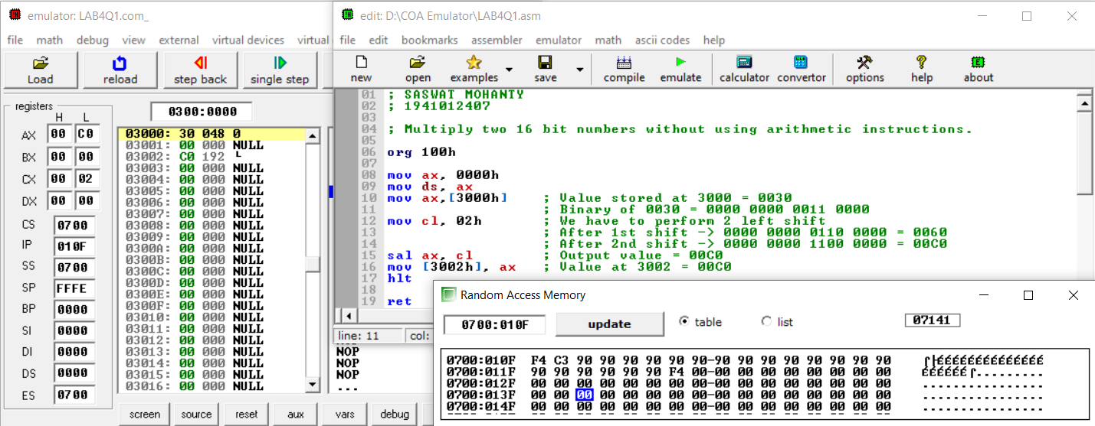

**For Obj. 2:**

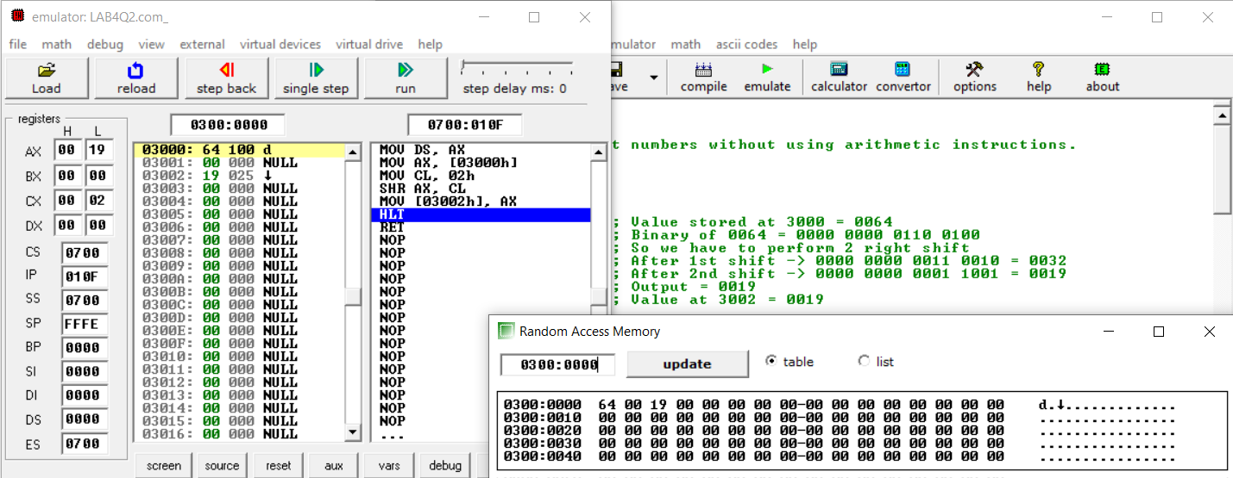

**Conclusion:**

From the above experiment we conclude that the given objective i.e. multiplication and division of any number can be done, provided the divisor is a multiple of 2, by shifting the number left or right ‘X’ times where x is the power to 2 which when calculated gives the divisor.

**IV. POST LAB:**

1. **Briefly discuss the instructions used in objectives 1.**

org 100h

mov ax, 0000h

mov ds, ax

mov ax,[3000h] *// at 3000 memory location we store the multiplicand*

*(In our case 0030h i.e. 48)*

mov cl, 02h *// here we store the multiplier (In our case 02h i.e. 4)*

sal ax, cl *// then we left shift the multiplicand 2 places to obtain*

*the output (In our case 00C0h i.e. 192.)*

mov [3002h], ax *// result stored in ax is then shifted to 3002 memory*

*location.*

hlt

ret

1. **Briefly discuss the instructions used in objectives 2.**

org 100h

mov ax, 0000h

mov ds, ax

mov ax,[3000h] *// at 3000 memory location we store the divisor*

*(In our case 0064h i.e. 100)*

mov cl,02h *// here we store the dividend (In our case 02h i.e. 4)*

shr ax,cl *// then we right shift the divisor 2 places to obtain*

*the output (In our case 0019h i.e. 25)*

mov [3002h], ax *// result stored in ax is then shifted to 3002 memory*

*location.*

hlt

ret

1. **What is the difference between the microprocessor and microcontroller?**

|  |  |
| --- | --- |
| **Microprocessor** | **Microcontroller** |
| Microprocessor consists of only a Central Processing Unit. | Micro Controller contains a CPU, Memory, I/O all integrated into one chip. |
| Microprocessor is used in Personal Computers. | Micro Controller is used in an embedded system. |
| Microprocessor uses an external bus to interface to RAM, ROM, and other peripherals. | Microcontroller uses an internal controlling bus. |
| Microprocessors are based on Von Neumann model | Micro controllers are based on Harvard architecture. |
| Microprocessor is complicated and expensive, with a large number of instructions to process | Microcontroller is inexpensive and straightforward with fewer instructions to process. |

1. **What is assembler?**

An assembler is a program that converts assembly language into machine code. It takes the basic commands and operations from assembly code and converts them into binary code that can be recognized by a specific type of processor.